**Analysis for “PERC - Nj Public Employment Relation commission ER Diagram”**

This ER (Entity Relationship) Diagram represents the model of New Jersey Public Employment Relation Commission Entity. The entity-relationship diagram of PERC shows all the visual instrument of database tables and the relations between PERC & Public Employers, Unions, public employees, commissioners & staff.

It used structure data and to define the relationships between structure data groups of PERC functionalities. The main Entities of the PERC are Public Employers, Unions, public employees and commissioners & staff.

**Public Employment Relation commission entities and their attributes:**

* **Commissioners & Staff Entity:** Department Entities of commissioners & staff are
  + **Commission:** Attributes of Commission are commission_id, name, Position, Term Expiration dates.
  + **Legal & Administration Section:** Attributes of Legal & Administration section are section_id**,** name and positions.
  + **Unfair Practices & Representation Section:** Attributes of Unfair & Representation Section are section_id, name and pisitions_held.
  + **Conciliation & Arbitration Section:** Attributes of Conciliation & Arbitration Section are section are section_id, name and pisitions_held.
* **Unions:** Attributes of Unions are staff_details, Unions_id and department and work_info.
* **Public Employees:** Attributes of public employees are employee_id, names, age and qualifications
* **Public Employers:** Department Entities of public Employers are
  + **Public Colleges and Universities:** Attributes of Public Colleges and Universities are college_id and staff_details.
  + **Local Public-School Districts and Charter Schools:** Attributes of Local Public-School Districts and Charter Schools areschool_id, staff_details and courses.
  + **Municipalities:** Attributes of Municipalities are regions, departments and worforce_info.
  + **Counties:** Attributes of Counties are counties_id, regions, departments and worforce_info.
  + **Autonomous agencies & Authorities:** Attributes of Autonomous agencies & Authorities are agencies_id, workforce_info.

**Relationships of PERC and Entities:**

* Public Employment Relation commission – Manages
  + Unions
  + Public Employees
  + Public Employers
* Public Employment Relation commission – consist of
  + Commissioners & Staff – Has/contains
    - Commission
    - Legal & Administration Section
    - Unfair Practices & Representation Section
    - Conciliation & Arbitration Section

**Description of PERC Database:**

* The details of all the employers and employees are stored in the respective tables.
* Each Entity (Commissioners & Staff Entity, Unions, Public Employees, Public Employers) contains primary key and unique keys.
* The entities Commission, Legal & Administration Section, Municipalities, Counties and Autonomous agencies & Authorities are related with foreign key section_id**.**
* There is one-to-one and one-to-many relationships available between Commissioners & Staff Entity, Unions, Public Employees, Public Employers
* All the entities are Commissioners & Staff Entity, Unions, Public Employees, Public Employers normalized and reduce delicacy of records.

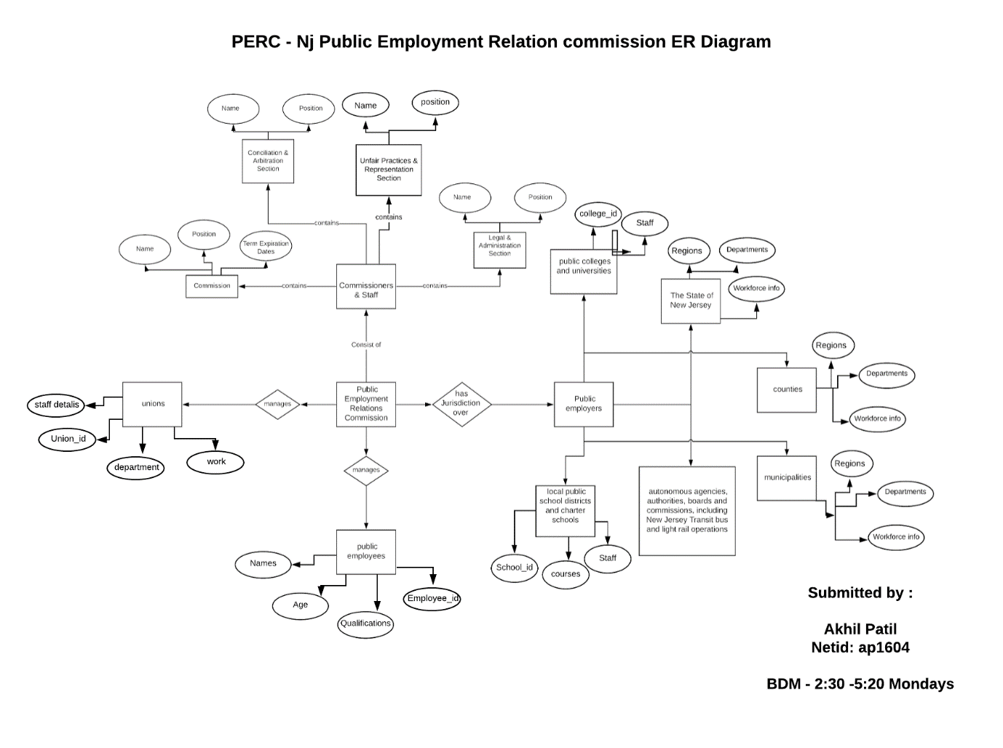

**Created and Submitted By:**

**Akhil Patil | BDM 2:30-5:20 Mondays| Netid: ap1604 | RUID : 190004529**